Case Study of

Washing Machine

INTRODUCTION :-

A washing machine(laundry machine, clothes washer, or washer) is a machine used to wash laundry, such as clothing and sheets. The term is mostly applied to machines that use water as opposed to dry cleaning (which uses alternative cleaning fluids, and is performed by specialist businesses) or ultrasonic cleaners.

WORKING OF WASHING MACHINE :-

A slow motor turns a shaft with many disks with bumps on them.The bumps activate micro switches which control water on and off, heater on and off, the main motor at different speeds (wash and spin) and the pump for emptying.It controls the programming of the machine i.e. Temp control, Spin cycles.

Components :-

1. **Water inlet control valve**

**2) Water pump**

**3) Tub**

**4) Agitator or rotating disc**

**5) Motor of the washing machine**

**6) Timer**

**7) Printed circuit board (PCB)**

**8) Drain pipe**

Block Diagram :-

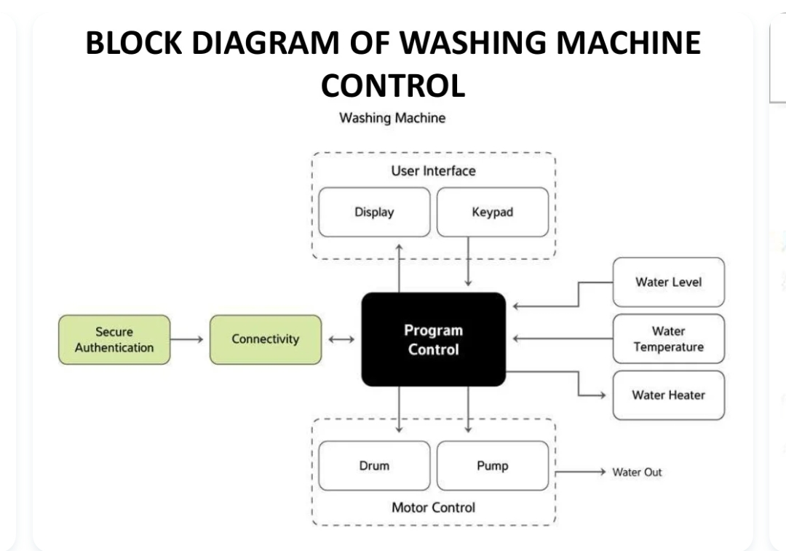

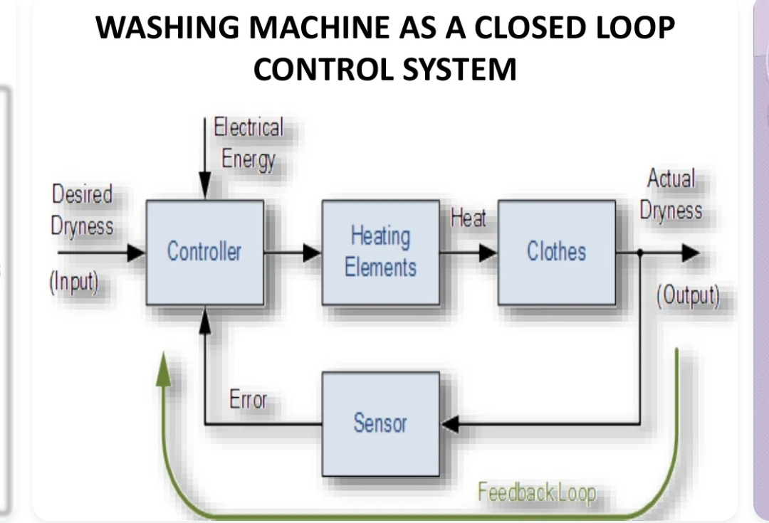

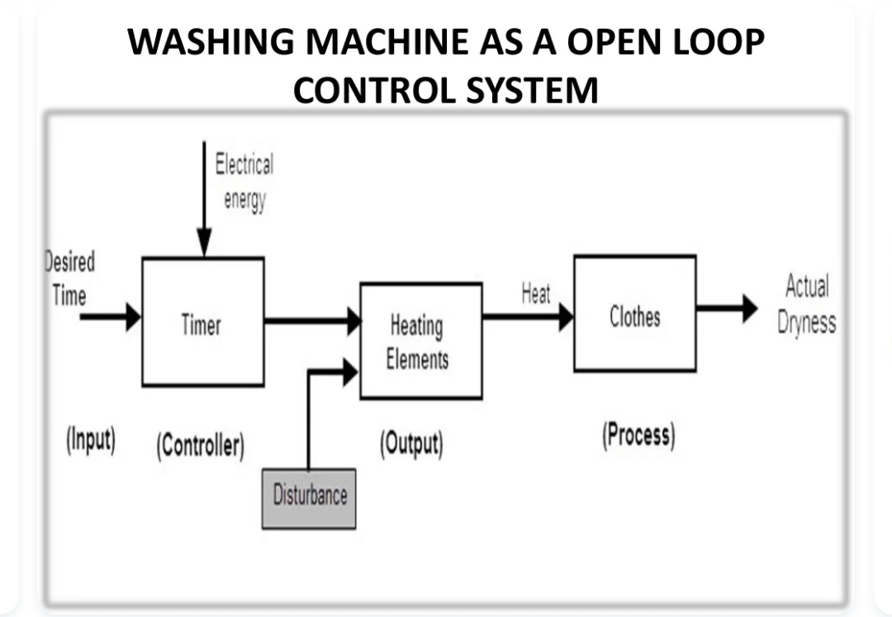

Requirements :-

High Level Requirements :-

1. Washing clothes
2. Drying clothes

Low Level Requirements :-

1. Durability of the components installed in the washing machine.
2. Effectiveness of the wash.
3. Resistibility from rust and corrosion of the materials used in the fabrication of the outer and the inner body of the washing machine.